ShopEZ
Full-Stack E-Commerce Platform
(Built with MongoDB, Express.js, React.js & Node.js (MERN Stack))
Project Documentation

1. Introduction

Project Title
ShopEZ — Full-Stack E-Commerce Platform (MERN Stack)
ShopEZ is a MERN stack-based e-commerce web application developed to provide users with a simple, efficient, and convenient online shopping experience. The platform enables customers to browse products, search by categories, add items to their cart, place orders, and track their purchases through an intuitive interface. It also includes administrative features for managing products and orders effectively. Designed with a responsive and user-friendly interface, ShopEZ aims to enhance customer satisfaction while simplifying the overall online shopping process.
Developed By: Suhana Sadh (Individual Project)

2. Project Overview

Purpose
ShopEZ is a full-stack e-commerce web application that lets users browse a product catalog, view detailed product information, add items to a cart, and complete a secure checkout. Registered administrators manage the product catalog and oversee orders through a dedicated admin panel. The goal of the project is to demonstrate a complete, production-style MERN workflow: a normalized MongoDB schema, a RESTful Express API protected by JWT authentication and role-based access control, and a responsive React front end that consumes that API.

Features
- Comprehensive product catalog with search, descriptions, pricing, and discounts.
- “Shop Now” button on every listing that opens a detailed product page.
- Order details page for entering shipping address, payment method, and product options (size, quantity).
- Secure, token-based checkout process with encrypted passwords.
- Order confirmation and a personal order-history view with live status (placed, shipped, delivered, etc.).
- Shopping cart that persists per user and supports quantity updates and removal.
- Role-based access: USER and ADMIN accounts, enforced both in the API and the UI.
- Admin dashboard to add/delete products and update order status.

3. Architecture

Frontend
The frontend is a single-page React application (built with Vite) located in /client. Routing is handled by react-router-dom, with two guard components — PrivateRoute and AdminRoute — that redirect unauthenticated or non-admin users before a protected page renders. Two React Context providers carry global state: AuthContext (current user + JWT) and CartContext (cart items, synced with the API). All HTTP calls go through a single shared Axios instance (src/utils/api.js) that automatically attaches the saved JWT to every request. The UI is styled with Bootstrap 5 for a responsive, mobile-friendly layout.

Backend
The backend is a Node.js/Express REST API located in /server, organized into clear layers: routes define the URL surface, controllers contain the business logic, models define the Mongoose schemas, and middleware handles cross-cutting concerns. The protect middleware verifies the JWT on incoming requests and loads the current user; the isAdmin middleware (used after protect) restricts a route to ADMIN accounts. Passwords are hashed with bcrypt.js before being stored, and a centralized error handler returns consistent JSON error responses.

Database
ShopEZ uses MongoDB Atlas (cloud-hosted MongoDB) with five collections, modeled with Mongoose schemas:
Collection | Key Fields | Purpose
users | username, email, password (hashed), usertype (USER/ADMIN) | Stores account credentials and role
admin | banner, categories[] | Site-wide storefront configuration
products | title, description, mainImg, carousel[], sizes[], category, gender, price, discount | Product catalog
cart | userId, productId, title, size, quantity, price, discount | Items a user has added to their cart
orders | userId, productId, name, address, pincode, paymentMethod, orderStatus, orderDate | Placed orders and their fulfillment status

4. Setup Instructions

Prerequisites
- Node.js v18 or later
- npm (bundled with Node.js)
- A MongoDB Atlas account (free tier) — https://www.mongodb.com/cloud/atlas
- VS Code (or any code editor) and Git

Installation
- Clone the repository / unzip the project, then open the folder in VS Code.
- Create a MongoDB Atlas cluster, a database user, and allow your IP under Network Access. Copy the connection string.
- In /server, copy .env.example to .env and set MONGO_URI (Atlas string), JWT_SECRET (any long random value), PORT, and CLIENT_URL.
- In /client, copy .env.example to .env and confirm VITE_API_URL points at your backend (default http://localhost:5000/api).
- From the project root, run: npm run install-all (installs dependencies in both /server and /client).
- Start the app (see Section 6: Running the Application).

5. Folder Structure

Client (React + Vite)
client/
├── index.html
├── vite.config.js
├── .env.example
└── src/
├── main.jsx # App entry point, providers, router
├── App.jsx # Route definitions
├── components/ # Navbar, ProductCard, PrivateRoute, AdminRoute
├── pages/ # Home, Login, Register, ProductDetail, Cart,
│ Checkout, Profile, admin/ (AdminDashboard,
│ ManageProducts, ManageOrders)
├── context/ # AuthContext, CartContext
├── utils/api.js # Shared Axios instance (attaches JWT)
└── styles/main.css

Server (Node.js + Express)
server/
├── server.js # App entry point, mounts all routes
├── .env.example
├── config/db.js # MongoDB Atlas connection
├── models/ # User, Admin, Product, Cart, Order (Mongoose)
├── middleware/ # authMiddleware (protect, isAdmin), errorHandler
├── controllers/ # Business logic per resource
├── routes/ # Express routers, one per resource
└── utils/generateToken.js

6. Running the Application
Run the backend and frontend in two separate terminals (or use npm run dev from the project root, which runs both at once via concurrently).

Backend
cd server
npm run dev # starts Express on http://localhost:5000

Frontend
cd client
npm start # starts the Vite dev server on http://localhost:3000

7. API Documentation
All endpoints are prefixed with /api. Protected endpoints require an Authorization: Bearer <token> header, obtained from /auth/login or /auth/register.
Method | Endpoint | Access | Description
POST | /auth/register | Public | Create a new account; returns user info + JWT
POST | /auth/login | Public | Authenticate; returns user info + JWT
GET | /auth/profile | Logged-in | Get the current user's profile
GET | /products | Public | List products (supports ?category, ?gender, ?search)
GET | /products/:id | Public | Get a single product by ID
POST | /products | Admin | Create a new product
PUT | /products/:id | Admin | Update an existing product
DELETE | /products/:id | Admin | Delete a product
GET | /cart | Logged-in | Get the current user's cart items
POST | /cart | Logged-in | Add an item to the cart
PUT | /cart/:id | Logged-in | Update a cart item's quantity
DELETE | /cart/:id | Logged-in | Remove an item from the cart
POST | /orders | Logged-in | Place an order (and clear the related cart item)
GET | /orders/my-orders | Logged-in | Get the current user's order history
GET | /orders | Admin | Get all orders across all users
PUT | /orders/:id/status | Admin | Update an order's fulfillment status
GET | /admin/config | Public | Get the storefront banner and category list
PUT | /admin/config | Admin | Update the storefront banner and category list

Example request/response — POST /api/auth/login:
Request body: { "email": "user@example.com", "password": "secret123" }
Response 200: { "_id": "665f...", "username": "jane", "email": "user@example.com",
"usertype": "USER", "token": "eyJhbGciOiJIUzI1NiIs..." }

8. Authentication
ShopEZ uses stateless JSON Web Token (JWT) authentication rather than server-side sessions.
- On registration or login, the server hashes/verifies the password with bcrypt.js and, on success, signs a JWT containing the user's database ID (utils/generateToken.js), valid for 7 days.
- The client stores the returned user object and token in localStorage and keeps it in AuthContext for the lifetime of the session.
- Every outgoing API request is intercepted by the shared Axios instance, which attaches the token as an Authorization: Bearer <token> header automatically — no per-page wiring needed.
- On the server, the protect middleware verifies the token's signature and expiry, then loads the matching user and attaches it to req.user for use in controllers.
- The isAdmin middleware, applied after protect on admin-only routes, checks req.user.usertype === "ADMIN" and rejects the request with 403 if it doesn't match.
- On the client, PrivateRoute and AdminRoute components mirror this logic, redirecting logged-out or non-admin users away from protected pages before they render.

9. User Interface
Key screens in the application:
- Home / Market — a searchable grid of product cards, each with a “Shop Now” button.
- Product Detail — full description, price/discount, size selector, and add-to-cart action.
- Cart — editable list of cart items with live quantity updates and a running total.
- Checkout — shipping address and payment method form that converts cart items into orders.
- Profile — account info and a history of the user's orders with live status badges.
- Admin Dashboard — tabs for Manage Products (add/delete catalog items) and Manage Orders (update fulfillment status).
Insert screenshots or short screen-recordings of each of the above screens here once the application is running locally (see Section 11).

10. Testing
Testing was performed manually across both the API and UI layers:
- API testing with Postman / Thunder Client: verified each endpoint in Section 7 for both success and error responses (invalid credentials, duplicate registration, missing fields, unauthorized/forbidden access).
- Authentication testing: confirmed protected routes reject requests with no token, an expired token, and a non-admin token on admin-only routes.
- Form validation: required fields, numeric fields (price, quantity), and email format were validated on both the client (HTML5 required/type attributes) and the server (Mongoose schema validation).
- Transactional integrity: verified that placing an order removes the corresponding item from the cart and that order totals reflect quantity and discount correctly.
- Responsive testing: checked the Bootstrap-based layout at desktop, tablet, and mobile breakpoints.
Recommended next step: add automated tests with Jest + Supertest for the API and React Testing Library for the frontend (see Section 13, Future Enhancements).

11. Screenshots or Demo
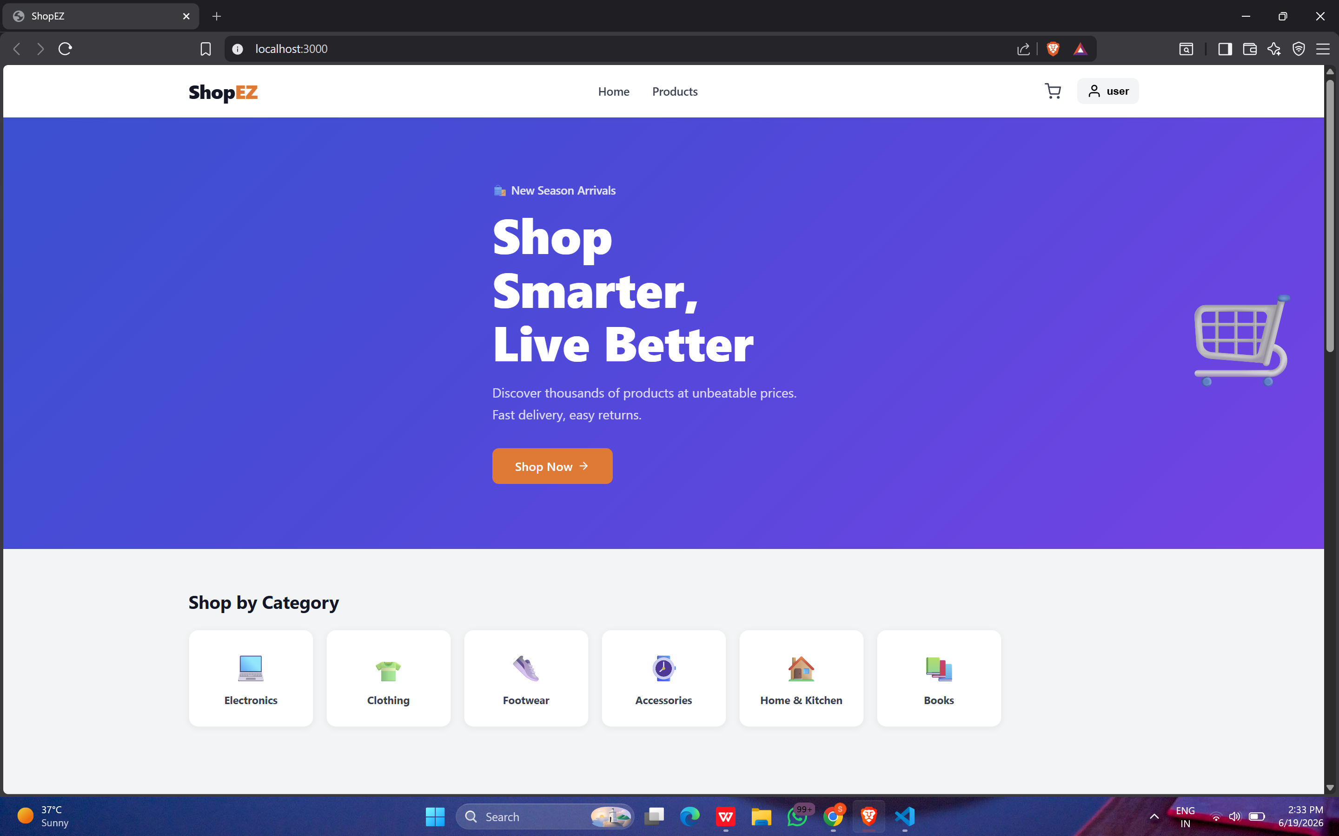

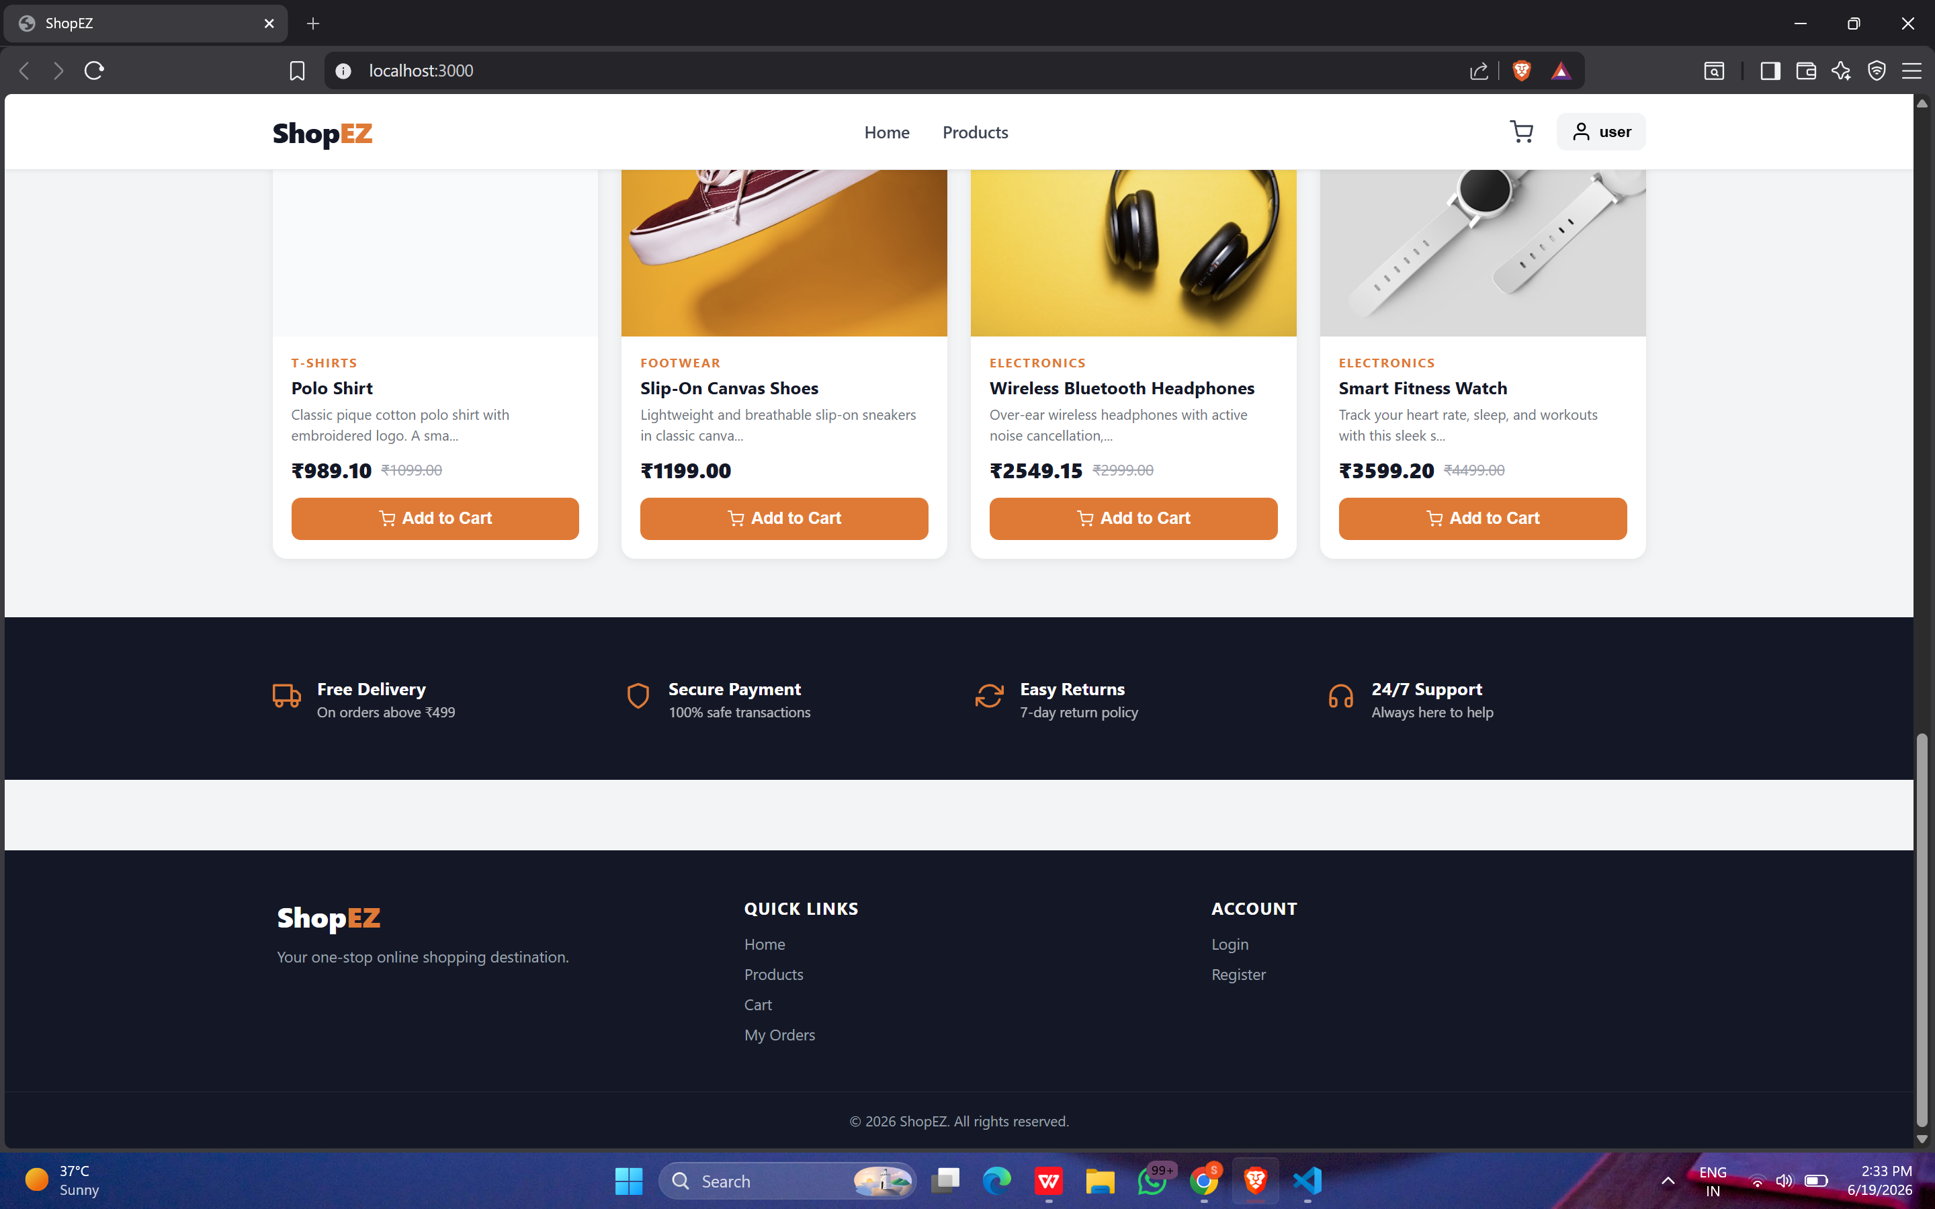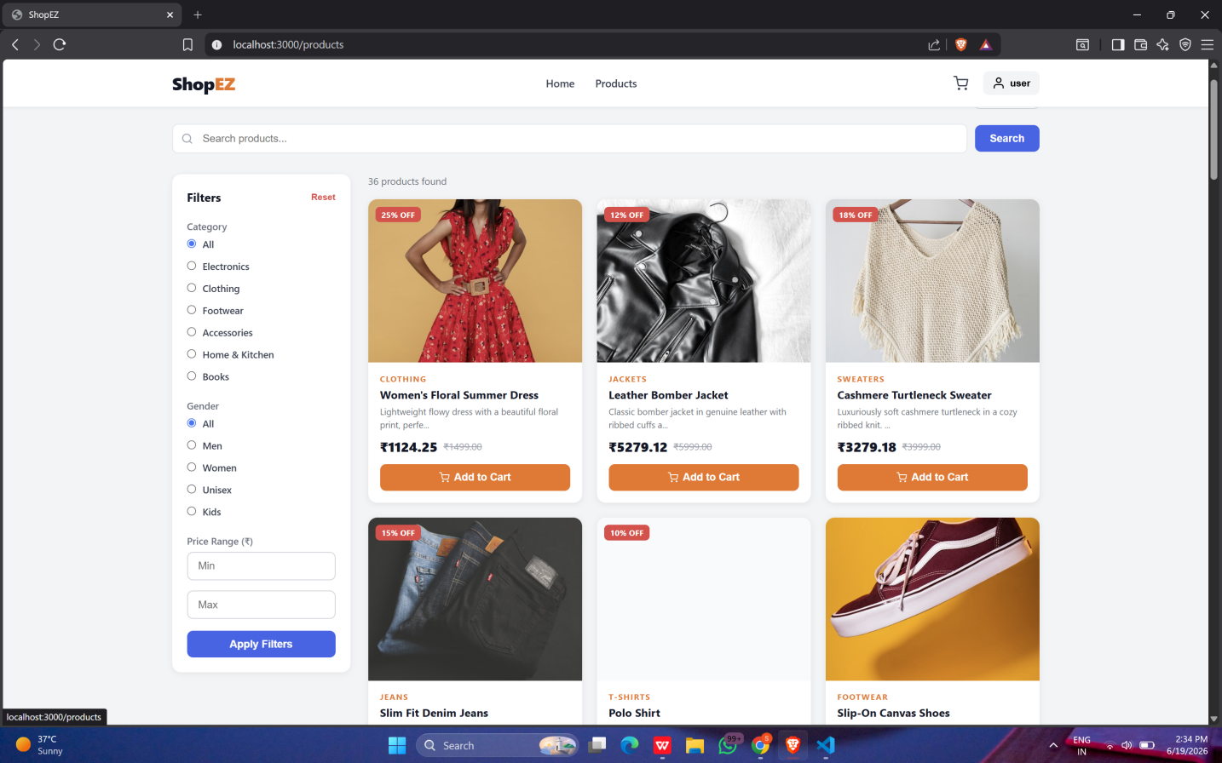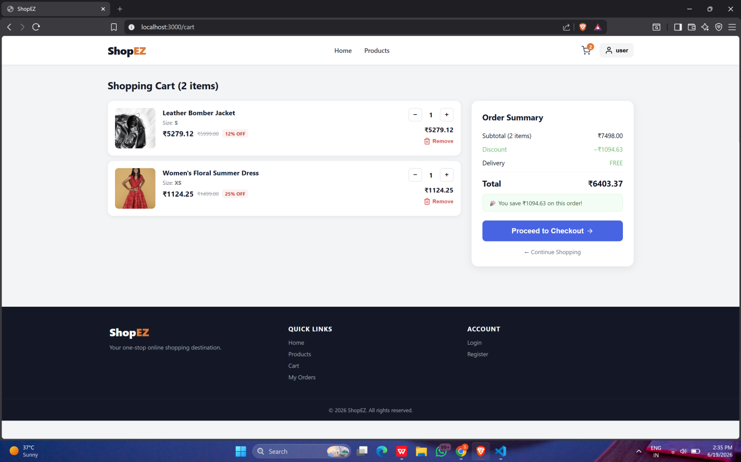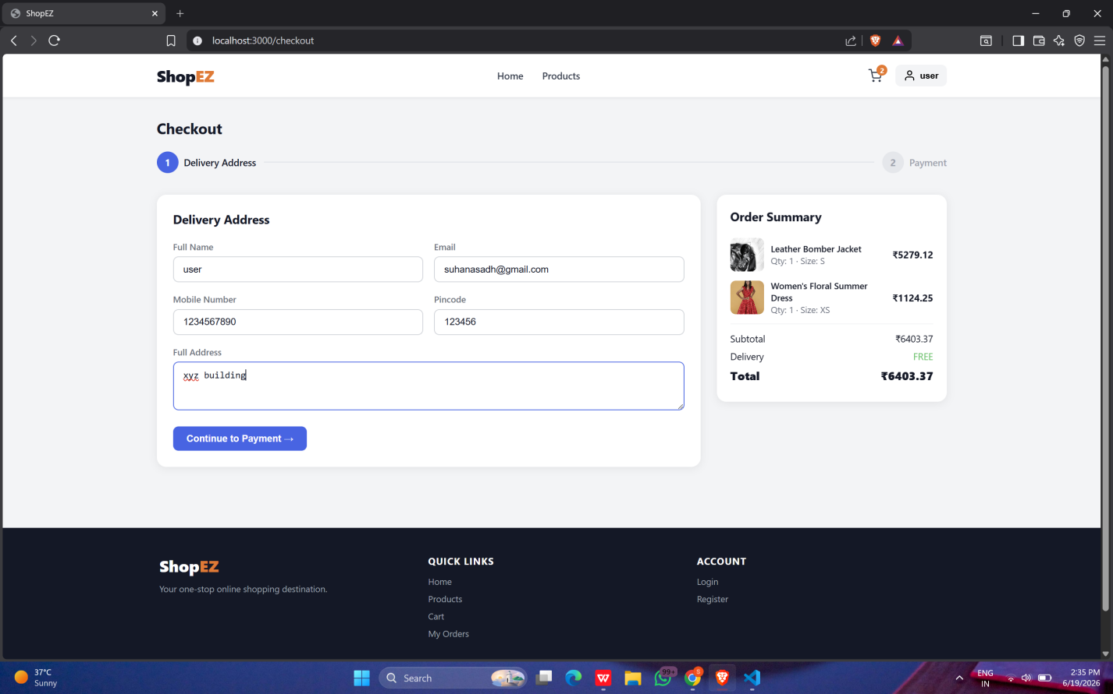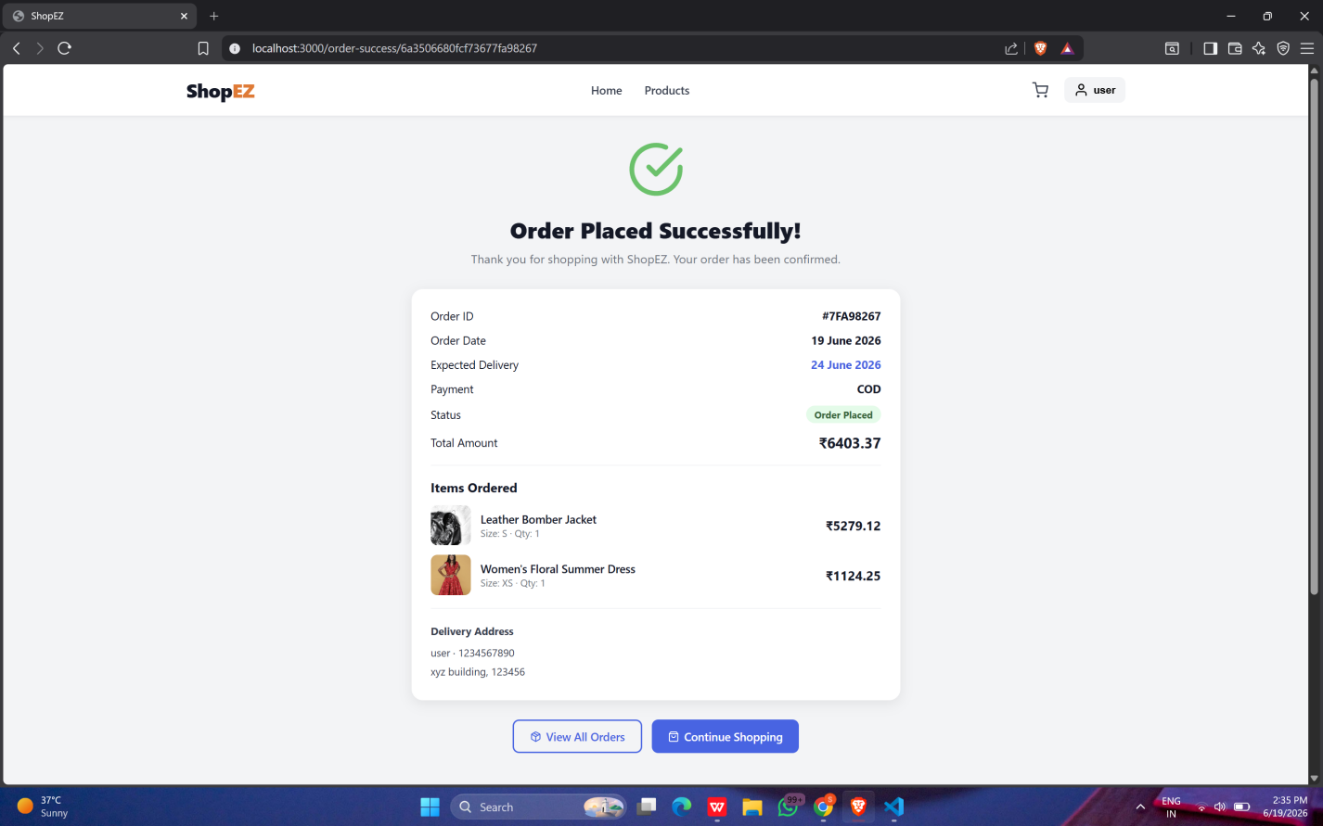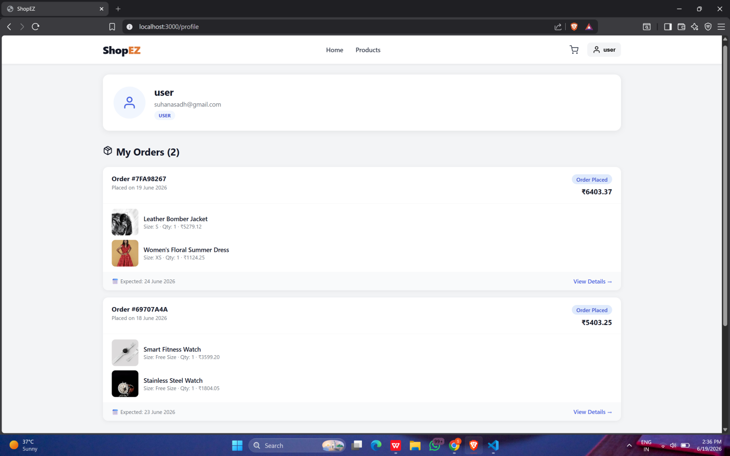

Demo Link: https://drive.google.com/drive/folders/1I-c54M0hyKls9PcyOSY7l_p7RohnH7qQ?usp=drive_link

12. Known Issues
- No real payment gateway is integrated; checkout simulates payment method selection only.
- Product images are referenced by URL rather than uploaded/stored (no file upload pipeline yet).
- There is no email verification or password-reset flow.
- The product list has no pagination, which may slow down the Home page as the catalog grows.
- Promoting a user to ADMIN requires manually editing the usertype field in MongoDB Atlas; there is no admin-invite UI.
- No automated test suite is included yet; testing is currently manual (see Section 10).

13. Future Enhancements
- Integrate a real payment gateway (e.g., Stripe or Razorpay) for live transactions.
- Add product image upload via a cloud storage provider (e.g., Cloudinary or AWS S3).
- Add pagination, filtering, and sorting to the product catalog.
- Add wishlists and customer product reviews/ratings.
- Add email notifications for order confirmation and status changes.
- Introduce refresh tokens and optional OAuth login (Google/GitHub).
- Build an admin analytics dashboard (sales over time, top products, inventory alerts).
- Add an automated test suite: Jest + Supertest for the API, React Testing Library for the UI.
- Convert the frontend into a installable PWA for offline-friendly browsing.

